ST RICHARD’S HOSPICE

JOB DESCRIPTION

Job Title: Events Fundraiser – 12 month Maternity cover, 4 days per week

Responsible to: Fundraising Manager

Accountable to: Director of Business and Income Generation

Our Values:

Our Core Values underpin everything we do and all employees are expected to comply with our Values and reflect these in their day-to-day work.

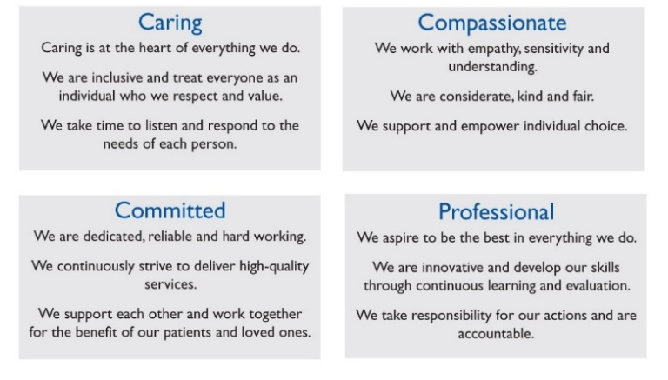

Job Summary:

St Richard's Hospice is at the heart of the Worcestershire community, providing specialist care and support to people living with a life-limiting illness and those closest to them.

We're looking for an enthusiastic and organised Events Fundraiser to join our Income Generation Team. The role is responsible for planning, delivering and evaluating a portfolio of fundraising events that inspire supporters, raise vital income and increase awareness of the hospice.

The portfolio includes a range of challenge and hospitality events, such as the Rainbow Run, Lantern Walk and Cheltenham Festival Preview Evening, with opportunities to develop and grow future events.

Working closely with colleagues across the Income Generation Team, Digital Marketing & Communications and the wider hospice, you'll deliver high-quality events, build strong supporter relationships and help create memorable experiences for participants, volunteers and sponsors.

The role is 22.5 hours per week (3 days) and will require occasional evening and weekend working to support fundraising events.

Main Duties and Responsibilities: -

1.0 Event Planning and Delivery

1.1 Lead on the planning, organisation and delivery of an agreed portfolio of fundraising events, ensuring they are delivered safely, professionally and within budget, contributing to agreed income and participation targets.

1.2 Develop detailed project plans for each event, coordinating timelines, venues, suppliers, volunteers and resources to ensure successful delivery.

1.3 Monitor event budgets, income and expenditure, providing regular updates to the Fundraising Manager and identifying opportunities to maximise net income and improve performance.

1.4 Evaluate all events through post-event analysis, reviewing financial performance, participant feedback and operational outcomes to identify learning and opportunities for future development.

1.5 Identify opportunities to improve existing fundraising events and develop new event ideas, using supporter feedback, sector trends and performance data to maximise participation, income and supporter engagement.

1.6 Contribute to the planning and development of the annual fundraising events programme, bringing new ideas and supporting the delivery of the Income Generation Team's strategic objectives.

2.0 Supporter Experience and Engagement

2.1 Deliver an excellent supporter experience throughout the participant journey, providing high-quality stewardship from initial enquiry through to post-event thank you and recognition.

2.2 Build and maintain positive relationships with participants, volunteers, sponsors, suppliers and community groups, encouraging repeat participation and long-term support for the hospice.

2.3 Work closely with the Marketing and Communications Team to develop engaging promotional campaigns that maximise event participation and raise awareness of St Richard's Hospice.

2.4 Respond to supporter enquiries promptly and professionally, always ensuring a high standard of customer service.

3.0 Governance and Compliance

3.1 Ensure all fundraising events are delivered in accordance with relevant legislation, the Fundraising Code of Practice, GDPR and St Richard's Hospice policies and procedures.

3.2 Complete comprehensive risk assessments for all events and implement appropriate health and safety measures to protect participants, volunteers, staff and members of the public.

3.3 Keep up to date with fundraising legislation, sector best practice and emerging trends, applying learning to continuously improve event delivery.

4.0 Administration and Reporting

4.1 Maintain accurate supporter and event records using the hospice CRM system, ensuring information is recorded promptly and in accordance with GDPR.

4.2 Produce regular reports on event performance, including income, expenditure, participation and return on investment, making recommendations for future improvements.

4.3 Work closely with colleagues across the Income Generation Team to ensure accurate financial reconciliation, event administration and reporting.

5.0 Team Working

5.1 Work collaboratively across the Income Generation Team, supporting colleagues with campaigns, appeals and larger fundraising events where required.

5.2 Build positive working relationships with colleagues across the hospice to ensure a joined-up approach to fundraising, supporter engagement and event delivery.

5.3 Represent St Richard's Hospice professionally at events, meetings and within the local community, acting as an ambassador for the organisation.

5.4 Share ideas, learning and best practice, contributing to the continuous development of the fundraising events programme and the wider Income Generation Team.

6.0 General Responsibilities

6.1 Safeguarding is everyone's responsibility. Follow the Hospice's safeguarding policies and report any concerns relating to children, young people or vulnerable adults in accordance with those policies.

6.2 Develop and maintain a good understanding of the work and services provided by St Richard's Hospice and positively promote the organisation at every opportunity.

6.3 Undertake relevant training and continuous professional development to maintain and develop knowledge and skills.

6.4 Undertake any other duties reasonably requested by the Fundraising Manager that are commensurate with the level and responsibilities of the role.

Personal Education and Development

- To use the hospice IT systems appropriately to maintain records and communicate internally and externally

- To maintain own personal development by attending appropriate courses and updates to maintain and develop skills and expertise

- To participate in the Individual Performance Review (IPR) process and respond to the agreed development plan

- To undertake statutory, mandatory and role enhancement training as directed

General

- To be aware of health and safety issues within the workplace and bring concerns to the attention of the line manager

- All staff are required to abide by St Richard’s Hospice policies and procedures, including confidentiality, equal opportunities and data protection.

This job description is not exhaustive and duties may be reviewed from time to time and revised and updated in consultation with the postholder.

Signed…………………………………………………Date………………………………..

ST RICHARD’S HOSPICE

PERSON SPECIFICATION

Job title: Events Fundraiser – 12 month maternity cover, 4 days per week

Responsible to: Fundraising Manager

Accountable to: Director of Business and Income Generation

 | Essential | Desirable
Education, Qualifications and Training | A good level of maths, English and general ICT skills (at least GCSE Grade 4 or above - or equivalent) | Educated to a degree level or equivalent  Degree in Business, Events Management, or Media & Communications
Experience | Experience of planning, organising and delivering events  Experience of managing multiple activities, deadlines and competing priorities | Experience in fundraising, or able to demonstrate other experience related to the role  Experience in a hospice, healthcare, charity or fundraising environment  Experience of delivering income generating activities
Knowledge | Knowledge and understanding of the importance of providing an excellent supporter/participant experience  Knowledge and understanding of budget management, income generation and event performance | Knowledge of CRM/ fundraising databases (e.g., Access CRM), financial analysis, return on investment metrics  Understanding of fundraising regulations, GDPR or the Fundraising Regulator’s code.
Skills and Abilities | Excellent interpersonal, communication, and presentation skills  Ability to build and maintain positive and effective relationships, encouraging repeat participation  Highly organised, able to manage multiple tasks or events simultaneously; strong budgeting, forecasting, and performance monitoring skills
Personal Qualities and Aptitudes | A compassionate and sensitive approach, particularly when engaging with fundraisers motivated by bereavement or personal stories  Desire to expand knowledge experience and skills and develop better technical ability (with training, direction and appropriate supervision)  Willing to work flexibly, including evenings and weekends, as required  Full driving licence and ability to travel locally to events, meetings or fundraising activities

